Sarah (Davis) Vine
March 17, 1872 – June 29, 1942

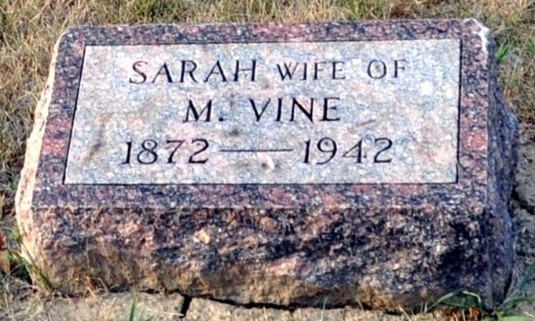
Photo by Deb Curry

Sarah Vine
in the Indiana, U.S., Death Certificates, 1899-2017
Name Sarah Vine
[Sarah Davis]
Gender Female
Race White
Marital Status Married
Age 79
Birth Date 17 Mar 1863(sic)
Birth Place Ohio
Death Date 29 Jun 1942
Death Place Pleasant, Adams, Indiana, USA
Death Registration Date 1942
Father Isaac Davis
Mother Mary Jones
Spouse Marian Vine
Informant Mrs. Dave Sovine; Pleasant Mills, Indiana
Burial July 1, 1942; Decatur Cemetery; Decatur, Indiana

