Mary Kathryn Vian
July 24, 1929 – October 18, 1943

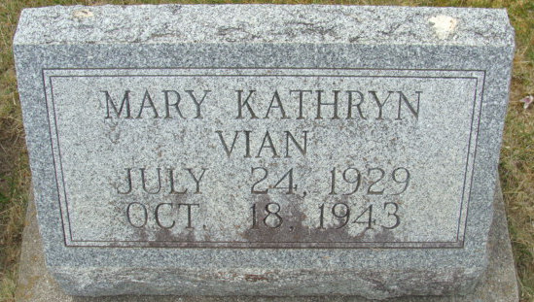
Photo by Alicia Kneuss

Mary Kathryn Vian
in the Indiana, U.S., Death Certificates, 1899-2017
Name Mary Kathryn Vian
Gender Female
Race White
Marital Status Single
Age 14
Birth Date 24 Jul 1929
Birth Place Decatur, Adams Co Indiana
Death Date 18 Oct 1943
Death Place Decatur, Adams, Indiana, USA
Death Registration Date 1943
Father Glen Vian
Mother Nellie Johnson
Informant Glen Vian; Decatur, Indiana
Burial October 20, 1943; Decatur Cemetery; Decatur, Indiana

