Marilyn J. (Robinson) Vetter
March 29, 1935 – February 10, 2019

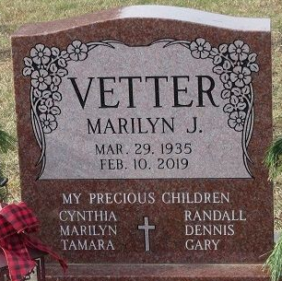
Photo by PLS

Marilyn J. Vetter, 83, of Decatur passed away on Sunday, February 10, 2019, at Adams Woodcrest. She was born on March 29, 1935, in Decatur, Indiana the daughter of the late Wilbur Robinson and the late Dorothy (Johnston) Robinson. She was a member of Zion Lutheran Church – Decatur.
Marilyn was a graduate of Decatur High school in 1953 and worked at General Electric in Decatur and Ft. Wayne for 30 plus years. Marilyn was a very good cook and passed her skill and love of cooking onto her children. In addition to her children and grandchildren, she loved flowers, gardens, ceramics, camping, chocolate, IU Basketball, and the beach. She also greatly enjoyed her cat, Sammy when he was alive.
Survivors include three daughters, Cynthia (Daniel) Gerber, Marilyn (Curtis) Main, and Tamara Vetter-Gase all of Decatur; two sons, Randall (Dianna) Vetter and Gary (Lori) Vetter all of Decatur; daughter-in-law, Lydia Vetter of Woodburn; two sisters, Sunya Garner and Karen (Gerry) Hilty all of Decatur; two brothers, Ronald (Gay) Robinson of Chester, VA and Gary Robinson of Decatur; 23 grandchildren; and 27 great-grandchildren.
She was preceded in death by a son, Dennis Vetter and a brother-in-law, Thomas Garner.
Funeral services will be held at 11:00 a.m. Thursday, February 14, 2019, at Zion Lutheran Church, Decatur with Pastor James Voorman officiating. Interment will follow in the Decatur Cemetery.
Friends will be received from 2-5 and 6-8 p.m. Wednesday, February 13, 2019, at the Zwick & Jahn Funeral Home Decatur and one hour prior to services Thursday at the church.
Preferred memorials can be made to Zion Lutheran Church- Decatur.

Zwick & Jahn Funeral Home, Adams County, Indiana
February 11, 2019

