Violet Floy (Casperson) Venis
July 14, 1901 – May 10, 1975

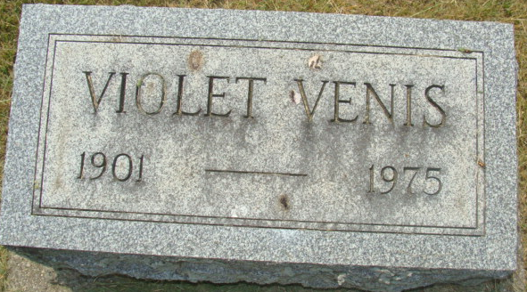
Photo by Alicia Kneuss

Violet Floy Venis, 73, of Fountain View Place, Elkhart, a former resident of Decatur, died this morning at Elkhart General Hospital. She had been in failing health two years.
Mrs. Venis was a member of the First United Methodist Church.
Born in Noble township, Auglaize County, O., on July 14, 1901, she was a daughter of A. J. and Laura O. Beavins-Casperson, and was united in marriage on April 16, 1935, to Merlin Venis, who preceded her in death.
Surviving are four daughters, Mrs. Paul (Eloise) Carter of Elkhart; Mrs. Clyde (Onnolee) Dennis of Middletown, O.; Mrs. Ted (Maxine) Kennedy of Lockport, N.Y.; Mrs. Frank (Eleanora) Sinacola of Grove Port, O.; two sisters, Mrs. Madeline McClain of Columbus, O., Mrs. Bernadine Grissom of West Carrolton, O.; one brother, Vernon Casperson of Lebanon, O.; 10 grandchildren and 13 great-grandchildren.
Funeral services will be held Tuesday at 2 p.m. at the Winteregg-Linn & Haggard Funeral Home, with Rev. Harold Leininger officiating. Burial will be in the Decatur Cemetery. Friends may call at the funeral home after 2 p.m. Monday.

Decatur Daily Democrat, Adams County, Indiana
Saturday, May 10, 1975

