Verona Verdella (McClymonds) Venis
November 11, 1902 – March 29, 1973

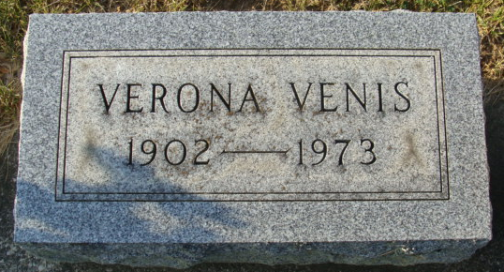
Photo by Alicia Kneuss

Verona V. Venis Dies Unexpectedly

Mrs. Verona V. Venis, 70, of 520 Grand Street, widow of Ray Venis, died unexpectedly at 7:30 a.m. Thursday at her home. She was a lifelong resident of the Decatur area and was a member of the Pocahontas and Women of the Moose.
Born on November 11, 1902, in Ohio, she was the daughter of Harrison and Ella Harmon-McClymonds, and was married on October 14, 1922, to Ray Venis. He died on December 31, 1970.
Surviving are five children; one son Raymond of Osceola; four daughters, Mrs. Virginia Chronister, Decatur; Mrs. Richard (Phyllis) Gase, Decatur; Mrs. Dale (Norma) Bird, Yoder; Mrs. George (Donna) Rothgeb, Hoagland; one sister, Mrs. Opal Dittman, of Arizona; one brother, Clyde McClymonds, Fort Wayne; 15 grandchildren and four great-grandchildren. One sister and one brother preceded her in death.
Funeral services will be held at 2 p.m. Saturday at the Winteregg-Linn Funeral Home, with Rev. Sylvester martin officiating. Burial will be in the Decatur Cemetery. Friends may call at the funeral home after 2 p.m. today. Pocahontas services will be held at 7:30 p.m. tonight and Women of the Moose services are slated at 8 o’clock.

Decatur Daily Democrat, Adams County, Indiana
Friday, March 30, 1973

