Thomas Venis
March 23, 1866 – June 4, 1937

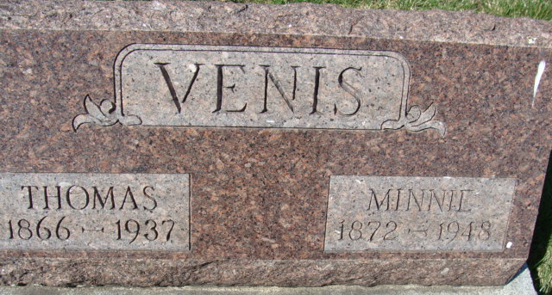
Photo by Alicia Kneuss

Thomas Venis
in the Indiana, Death Certificates, 1899-2011
Name: Thomas Venis
Gender: Male
Race: White
Age: 71
Marital Status: Married
Birth Date: 23 (or 27) Mar 1866
Birth Place: Indiana
Death Date: 4 Jun 1937
Death Place: Decatur, Adams, Indiana, USA
Father: Rudoph Venis
Mother: Elizabeth Hower
Spouse: Minnie Venis
Informant: Mrs. Floyd Cook, Decatur, Ind.
Burial: June 7, 1937 Decatur Cem.

