Ray Venis
October 8, 1892 – December 31, 1970

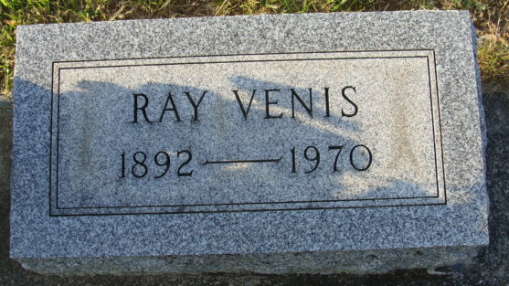
Photo by Alicia Kneuss

Ray Venis Is Dead After Long Illness

Ray Venis, 78, of 520 Grant Street, well known retired painter, died at 3:05 a.m. today at the Lakeview Nursing Home. He had been ill for the past year and in critical condition for four months.
He was born in Wells County Oct. 8, 1892, a son of Thomas and Minnie Brothers-Venis, and was married to Verona V. McClymonds Oct. 14, 1922.
Surviving are his wife; one son, Raymond Venis, Jr., of Osceola; four daughters, Mrs. Paul (Virginia) Chronister and Mrs. Richard (Phyllis) Gase, both of Decatur; Mrs. Dale (Norma) Bird of Yoder and Mrs. George (Donna) Rothgeb of Hoagland; three sisters, Mrs. Floyd (Iva) Cook and Mrs. Florence Foreman, both of Decatur, and Mrs. Jennie Albrecht of Fort Wayne; one brother, Everett Venis of Fremont; 15 grandchildren and one great-grandchild. One brother and one sister are deceased.
Funeral services will be conducted at 2 p.m. Saturday at the Winteregg-Linn Funeral Home, with Rev. Sylvester Martin officiating. Burial will be in the Decatur Cemetery. Friends may call at the funeral home after 2 p.m. Friday until time of the services.

Decatur Daily Democrat, Adams County, Indiana
Thursday, December 31, 1970

**
Venis Funeral This Afternoon
Services will be held at 2 p.m. today at the Winteregg-Linn Funeral Home for Ray Venis, retired painter, who died Thursday morning after an extended illness. Rev. Sylvester Martin will officiate, and burial will be in the Decatur Cemetery.
The name of a daughter, Mrs. Leoma Lugo, of Berwyn, Ill., was unintentionally omitted from the list of survivors published in Thursday's Daily Democrat. There are also 17 grandchildren and five great-grandchildren.

Decatur Daily Democrat, Adams County, Indiana
Unknown date

