Minnie (Brothers) Venis
December 22, 1872 – August 24, 1948

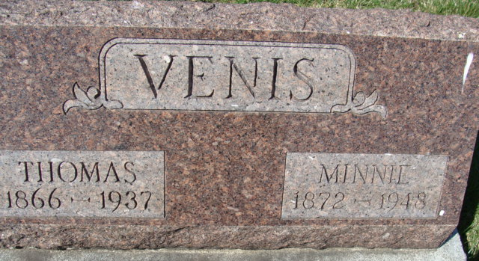
Photo by Alicia Kneuss

Mrs. Minnie Venis Dies Last Evening
Funeral Services Friday Afternoon

Mrs. Minnie Venis, 75, a lifelong resident of Adams County, died at 6:15 o'clock Tuesday evening at the home of a brother, John Brothers, with whom she resided. She had been in failing health for five years. Born Dec. 22, 1872, in Adams County, she was a daughter of Oscar and Sarah Brothers. Her husband, Thomas Venis, died several years ago. She was a member of the Trinity Evangelical United Brethren Church.
Surviving are three sons, Ray and Merlin Venis, both of Decatur, and Everett Venis of Anderson; four daughters, Mrs. Evangeline Eyanson of Decatur, Mrs. Floyd Cook of Waynedale, Mrs. Jennie Amrine of Fort Wayne and Mrs. Florence Foreman of Anderson; two brothers, John and Charles Brothers, both of Decatur; three sisters, Mrs. Lucy Shell of Decatur, Mrs. James Thatcher of Fort Wayne and Mrs. Kittie Daniels of Bobo; 22 grandchildren and 21 great-grandchildren.
Funeral services will be held at 2 p.m. Friday at the Black Funeral Home, with the Rev. G. A. Eddy officiating. Burial will be in the Decatur Cemetery. Friends may call at the funeral home after 7 o'clock this evening.

Decatur Daily Democrat, Adams County, Indiana
August 25, 1948

**
Indiana, U.S., Death Certificates, 1899-2017
Name Minne Venis [Minne Brothers]
Gender Female; Race White
Marital Status Widowed
Age 75
Birth Date 22 Dec 1872; Birth Place Adams County
Death Date 24 Aug 1948; Death Place Decatur, Adams, Indiana, USA
Father Oscar Brothers
Mother Sarah Helm
Spouse Thomas Venis
Informant John Brothers
Burial August 27, 1948; Maplewood Cemetery; Decatur, Indiana

