Merlin Venis
September 15, 1909 – February 3, 1958

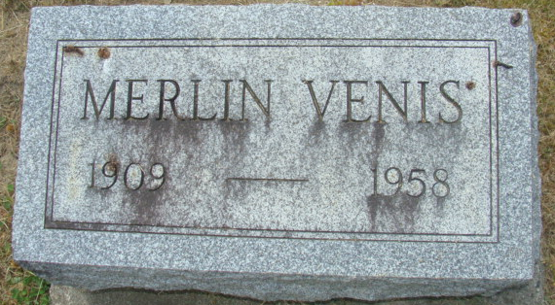
Photo by Alicia Kneuss

Merlin Venis Dies Unexpectedly Today
Heart Attack Fatal To Local Resident

Merlin Venis, 48, of 722 Mercer Avenue, a lifelong resident of this community, died at 9:15 o'clock this morning at the Adams County Memorial Hospital of a heart attack suffered earlier this morning. He had been employed at the Central Soya Co. in this city for the past 15 years. Born in St. Mary's Township Sept. 15, 1909, he was a son of Thomas and Minnie Venis. Mr. Venis was a member of the Trinity Evangelical United Brethren Church.
Surviving are his wife, Violet; four step-daughters, Mrs. Eloise Carter of Elkhart, Mrs. Onna Lee Dennis of Middletown, O., Mrs. Maxine Kennedy of Pryor, Okla., and Mrs. Eleanora Sinacola of Columbus, O.; two brothers, Everett Venis of Anderson, and Ray Venis of Decatur, and four sisters, Mrs. Floyd Cook and Mrs. Raymond Eyanson of Decatur, Mrs. James Longfellow of Warsaw, and Mrs. Jennie Amerine of Fort Wayne.
Funeral services will be held at 2 p.m. Thursday at the Gillig & Doan funeral home, the Rev. Carl Hawkins officiating. Burial will be in the Decatur Cemetery. Friends may call at the funeral home after 2 p.m. Tuesday until time of the services.

Decatur Daily Democrat, Adams County, Indiana
February 3, 1958

**
Indiana, U.S., Death Certificates, 1899-2017
Name Merlin Venis
Gender Male
Race White
Marital Status Married
Age 48
Birth Date 15 Sep 1909
Birth Place Adams County, Indiana
Death Date 3 Feb 1958
Death Place Decatur, Adams, Indiana, USA
Death Registration Date 1958
Father Thomas Venis
Mother Minnie Brothers
Informant Mrs. Violet Venus; wife; Decatur, Indiana
Burial February 6, 1958; Decatur Cemetery; Decatur, Indiana

