Martin Sylvester Venis
March 10, 1868 – August 11, 1952

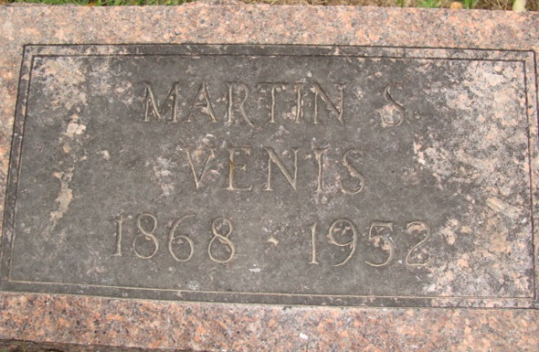
Photo by Alicia Kneuss

Martin Sylvester Venis
in the Indiana, Death Certificates, 1899-2011
Name: Martin Sylvester Venis
Gender: Male
Race: White
Age: 84
Marital Status: Married
Birth Date: 10 Mar 1868
Birth Place: Adams Co Indiana
Death Date: 11 Aug 1952
Death Place: Decatur, Adams, Indiana, USA
Father: Rudolph Venis
Mother: Elizabeth Hower
Informant: Mrs. Martin Venis of Decatur, Ind.
Burial: Aug. 14, 1952 Maplewood Cem., Decatur, Ind.

