Lily May Venis
September 14, 1892 – August 30, 1925

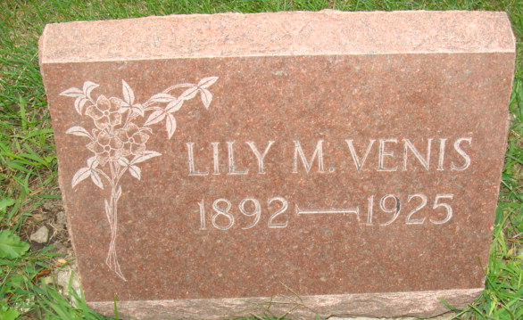
Photo by Alicia Kneuss

Lillie May Venis
in the Indiana, Death Certificates, 1899-2011
Name: Lillie May Venis
[Lillie May Venis]
Gender: Female
Race: White
Age: 33
Marital Status: Single
Birth Date: 14 Sep 1891
Birth Place: Indiana
Death Date: 30 Aug 1925
Death Place: Decatur, Adams, Indiana, USA
Father: Martin S Venis
Mother: Sarah Baum
Informant Martin Venis; Decatur, Indiana
Burial: Sept. 1, 1925 Decatur Cem.

