Glenn Harold Venis
August 12, 1899 – October 15, 1928

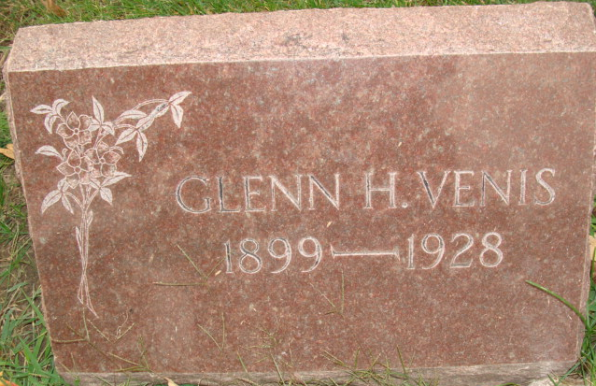
Photo by Alicia Kneuss

War Veteran Kills Self
By Times Special
Decatur, Ind., Oct. 17 – Funeral services were held today for Glen H. Venis, 29, World war veteran, who committed suicide by poisoning. He is believed to have been despondent over money troubles.

Unknown source

**
DECATUR MAN ENDS LIFE BY TAKING CARBOLIC ACID
(Special to the News Sentinel)

DECATUR, Ind., Oct. 16 – Glen Harold Venis, aged 29, committed suicide Monday by drinking carbolic acid at his home. Mrs. Venis was preparing breakfast when she heard her husband call. Upon going to him, she found him in bed with the empty bottle beside him. He died an hour later. Financial worries are given as the cause of his act.
He is survived by the widow and one son.
He was an inspector at the General Electric plant for the past five years. During World War, he was a member of the One Hundred and Thirty-Eighth field artillery, and saw service overseas.
Unknown source

**
U.S., Headstone Applications for Military Veterans, 1861-1985
Name Glenn Venis
Unit 139 F. A.
Company Btry A
Death Date 15 Oct 1928
Cemetery Maplewood
Cemetery Location Decatur, Indiana, USA
**
Indiana, U.S., Death Certificates, 1899-2017
Name Glen Venis
Gender Male
Race White
Marital Status Married
Age 29
Birth Date 12 Aug 1899
Birth Place Indiana
Death Date 15 Oct 1928; suicide
Death Place Decatur, Adams, Indiana, USA
Death Registration Date 1928
Father Martin Sylvester Venis
Mother Sarah E Baum
Spouse Hazel
Informant Mrs. Hazel Venis; Decatur, Indiana
Burial October 17, 1928; Decatur Cemetery

