Barbara Jacqueline Venis
September 3, 1929 – January 28, 1938

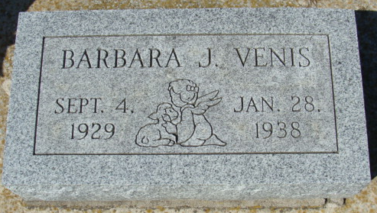
Photo by Alicia Kneuss

DEATH CLAIMS BARBARA VENIS
Young Girl Dies At Local Hospital After Week’s Illness

Miss Barbara Jacqueline Venis, 8-year-old daughter of Merlin and MaDonna Venis, died at the Adams County Memorial Hospital at 8:50 o’clock Friday evening following a week’s illness. The little girl had been living with her grandfather, Earnest Krugh of 219 South Eighth Street.
Barbara was born In Decatur, September 4, 1929. Her mother, and one sister preceded her in death. Her father and a stepmother survive.
She resided in Decatur all her life, except a few months in Michigan.
The body was removed from the hospital to the Gillig and Doan Funeral Home, where it may be viewed until time of the funeral. Funeral services will be held Monday afternoon at 1:30 o’clock at the funeral home, and at 2 o’clock at the United Brethren Church, with Rev. James A. Weber officiating. Burial will be in the Decatur Cemetery.

Decatur Daily Democrat; Adams County, Indiana
Saturday, January 29, 1938
**

Indiana, U.S., Birth Certificates, 1907-1944
Name Barbarba Jaqueline Venis
Gender Female
Birth Date 3 Sep 1929
Birth Place Decatur, Adams, Indiana, USA
Father Merlin Venis; age 19
Mother Madonna J Krugh; age 17; 1st child
Certificate Number 39797
Roll number 40474_356495
Volume Range 76 - 80

