Jaffray J. Vega
December 3, 1892 – July 8, 1940

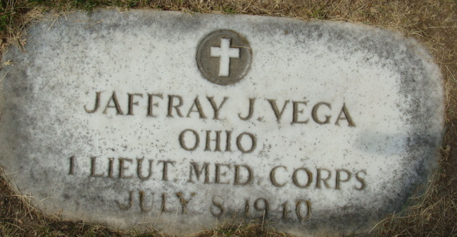
Photo by Alicia Kneuss
VEGA

Decatur, July 8 – Dr. J. J. Vega, resident surgeon at the Hines Veterans Hospital at Hines, Illinois died at Hines today after a long illness, according to word received here.
The body is being brought to the Black Funeral Home here for funeral services and burial.
The widow is the former Portia Thomas of this city.
Journal-Gazette, Allen County, Indiana
July 9, 1940
**
Decatur, July 9 – Funeral services will be held at the St. Mary’s Catholic Church at 9 o’clock Thursday morning for Dr. Jaffray J. Vega, 47, who died Monday afternoon at the Hines Hospital at Chicago. Burial will be in the Decatur Cemetery. Military services will be held.
Dr. Vega was a first lieutenant in the Medical Corps during the World War.
Surviving is the widow; the father, Anthony of New Orleans, Louisiana; two brothers, Eddie of Buffalo, New York and Dr. Clafin Vega of New York City; and a sister, Mrs. Norma Landry of McAlley, Texas.
Journal-Gazette, Allen County, Indiana
July 10, 1940

**
Illinois, U.S., Deaths and Stillbirths Index, 1916-1947
Name Jaffray J. Vega
Birth Date 3 Dec 1892
Birth Place Donaldsonville, Louisiana
Death Date 8 Jul 1940
Death Place Hines, Cook, Illinois
Burial Date 10 Jul 1940
Burial Place Decatur, Adams, Indiana
Cemetery Name Mapelwood
Death Age 47
Occupation Physician Veterans Admin
Race White
Marital Status M
Gender Male
Residence Decatur, Adams, Indiana
Father Name Anthony D. Vega
Father Birth Place Louisiana
Mother Name Eliza Vives
Mother Birth Place Louisiana
Spouse Name Portia Vega
Comments Doctor. World War I Veteran.
FHL Film Number 1832000

