Mary Elizabeth (Christen) Vaughn
September 20, 1880 – March, 1967

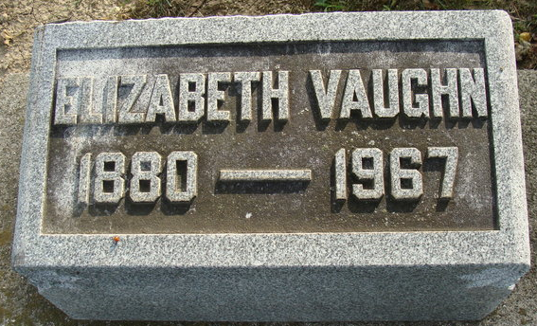
Photo by Alicia Kneuss

Elizabeth Vaughn
in the U.S., Social Security Death Index, 1935-2014
Name Elizabeth Vaughn
Social Security Number xxx
Birth Date 20 Sep 1880
Issue year 1958-1959
Issue State Illinois
Last Residence 33063, Pompano Beach, Broward, Florida, USA
Death Date Mar 1967

**
Florida, U.S., Death Index, 1877-1998
Name Mary Elizabeth Vaughn
Gender Female
Race White
Death Date Mar 1967
Death Place Broward, Florida, United States

