Fred S. Vaughn
1879 – November 25, 1912

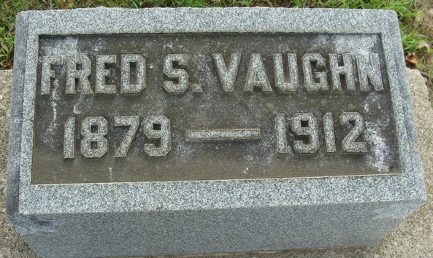
Photo by Alicia Kneuss

COMMITS SUICIDE
Fred Vaughn, Former Decatur Mail Carrier, Swallows Poison at EVANSTON, ILL
Had Resided There Several Months -Employed as Linotype Operator

Fred S. Vaughn, a former Decatur young man, for several years a Decatur mail carrier, residing with his family the past six months at Evanston, Ill., committed suicide Monday night by swallowing poison. Word of the death first came Monday evening in a telegram from Mrs. Vaughn at Evanston to relatives in this city. No details were given, and the first definite word that came to Decatur citizens was the following Item in this morning's Chicago Record Heald:
Fred S. Vaughn, a linotype operator, living at 812 Clark Street, Evanston, committed suicide by swallowing poison yesterday. Vaughn, who was 33 years old, recently had been having trouble with his wife, and failed to support her. Mrs. Vaughn was working in a store in Evanston and on her return home from work last evening she found her husband dead. When the word came Monday evening, Charles N. Christen, who is a brother-in-law of the deceased, left on the first train, about 2 o'clock this morning, for Chicago. He stated that he would wire relatives here concerning the details and at a late hour this afternoon no word from him had been received. The deceased was well known in this city, where the greater part of his life had been spent.
He was born near Angola, where his father and family still live, his mother having died many years ago. After his mother's death he was received into the family of his mother's cousins, the Misses Lell and Sarah Segur, who resided in Decatur, who reared him with great care. He was educated in the Decatur High School, and later entered a printing office, where he learned the trade of a printer. He was married in young manhood to Miss Bess Christen, a daughter of Mrs. Mary Christen, of Tenth Street, this city. When the Spanish American war broke out, he enlisted and served through the war.
After leaving the printer’s trade he entered the civil service, and became city mail carrier, being one of the first mail carriers established in the city. A short time ago he resigned and returned to the printer’s life. He mastered the linotype’s profession and for a year or so has been employed as a linotype operator. He worked some time in Tennessee, and at Hamilton, Ohio, and about six months ago went to Chicago, where he secured a position with his family living at Evanston.
Besides his wife, he leaves one son, Crede.
Those who know him best here are not surprised at his rash deed. It is said that his mind has seemed to be peculiarly affected for some time, and it is said that at one time while residing in this city a short while ago he attempted to take his own life.
He was of a jovial, friendly nature, and he has a host of friends here who learn of his sad ending with regret. Late this afternoon a telegram came from Mr. Christen with word that the body would be brought here for burial, arriving tomorrow morning at 2:48 o’clock over the Erie Railroad. The message stated that the funeral would be held tomorrow.

Decatur Daily Democrat; Adams County, Indiana
Tuesday, November 26, 1912
**
Indiana, U.S., Marriages, 1810-2001
Name Fred S Vaughn
Gender Male
Event Type Marriage Registration (Marriage)
Marriage Date 15 Oct 1897
Marriage Place Indiana, United States
Spouse Elizabeth Christen
Officiator John H Lenhart
Page 332
FHL Film Number 002321471

**
Fred S. Vaughan from tree Kathy Vaughan Brisbin
Birth 1879 Indiana, USA
Residence 1880 Steuben, Indiana, USA
Death 25 Nov 1912 Evanston, Cook, Illinois, USA
Father Elmer M. Vaughan (1858-1926)
Mother Laura Dehaven (Born 1853)

