Harold L. Vanhorn
August 23, 1937 – December 14, 2024

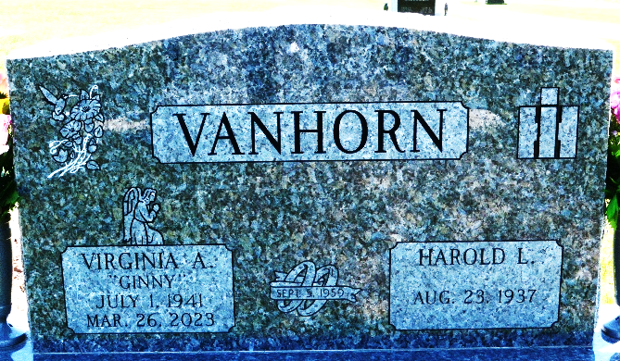
Photo by Deb Curry

Harold L. Vanhorn, 87, of Decatur, Indiana passed away peacefully Saturday morning, December 14, 2024, at Stillwater Hospice Home in Fort Wayne, Indiana. He was born on August 23, 1937, in Van Wert, Ohio to the late Delmer and Lovina (Schaadt) Vanhorn. Harold was united in marriage to Virginia A. Thatcher on September 5, 1959, at the United Brethren in Christ Church in Rockford, Ohio, and she preceded him in death on March 26, 2023.
Harold honorably served his country in the United States Army during the Cold War and was a member of the American Legion Post #43.
Harold was a member of the First United Methodist Church in Decatur.
Over the years, he generously donated his time to many different organizations, including the Pleasant Mills Lions Club, longtime 4-H Leader for St. Mary’s Township, 4-H Dairy Committee, Scout Master for Troop #70, and the Massey-Harris Collectors Association.
He graduated from Decatur High School in 1955. Harold worked as a Test Mechanic for International Harvester/Navistar, retiring in 2001 after more than 42 years of service. Additionally, he farmed and previously milked Registered Ayrshire cows.
Harold over the years enjoyed woodworking, antique tractors, and time spent outdoors gardening. In his retirement, Harold and Ginny traveled to many different places and almost always a grandchild was involved in the trip. Over the years, Harold valued the friendships made with their Amish neighbors.
He is survived by his son, Gregory “Greg” Vanhorn of Decatur, Indiana; son, Michael “Mike” (Stacy) Vanhorn of Greenville, Ohio; son, Brian (Jenny Kaley) Vanhorn of Decatur, Indiana; brother, Kenn Vanhorn of Decatur, Indiana; brother, Rick (Kathy) Vanhorn of Lucas, Texas; six grandchildren, Kristen (Nate) Foote, Adam McCollough, Emily (Alex) Stucke, Noah Vanhorn, Kyle (Alexis) Blevins, and Brice Vanhorn; and five great-grandchildren, Kai Jones, Nora Stucke, Henry Stucke, Gabriel Stucke, and Josie Foote.
Harold was preceded in death by his daughter, Penelope “Penny” McCollough; sister, Marilyn Weidman; and two brothers, Dave Vanhorn and Bruce Vanhorn.
A funeral service will be held at 10:30 a.m. Friday, December 20, 2024, at the Zwick & Jahn Funeral Home in Decatur, Indiana with Pastor Harold Klinker officiating. Burial will follow at Decatur Cemetery with military honors being rendered by the United States Army Honor Guard and the American Legion Post #43. The family will receive friends from 3:00 to 5:00 and 6:00 to 8:00 p.m. Thursday, December 19, 2024, at the Zwick & Jahn Funeral Home in Decatur, Indiana, and one hour prior to the service on Friday.
Preferred memorials can be given to the Adams County 4-H or the ACCF – Cancer Fund.

Zwick & Jahn Funeral Home, Adams County, Indiana
December 15, 2024

