Dudley S. Vanhorn
February 9, 1963 – May 8, 2023

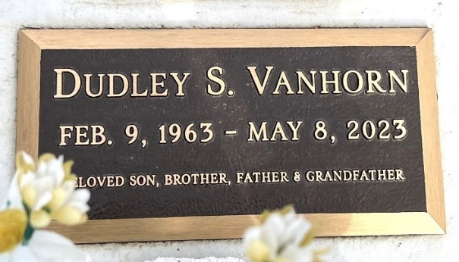
Photo by Deb Curry

Dudley S. Vanhorn, 60, of Goshen formerly of Decatur, IN, passed away Monday, May 8, 2023, at his residence. He was born in Decatur, on February 9, 1963, the son of David and Dorothy (Geyer) Vanhorn.
He was employed at Forest River, in Goshen, Indiana.
He was preceded in death by his father, David Vanhorn.
Visitation will be from 2:00 – 5:00 p.m. Friday, May 12, 2023, at Haggard-Hirschy & Zelt Funeral Home.

Haggard & Sefton Funeral Home, Adams County, Indiana
May 9, 2023
**

Dudley S. Vanhorn, 60, of Goshen, formerly of Decatur, IN, passed away Monday, May 8, 2023, at his residence. He was born in Decatur, on February 9, 1963, the son of David and Dorothy (Geyer) Vanhorn. He was employed at Forest River, in Goshen, Indiana.
Dudley is survived by his mother, Dorothy Vanhorn of Decatur; a son, Colby (Emily) Vanhorn of Decatur; a sister, Dove (Azwan) Mattaridi of Columbus, OH; a brother, Dean (Marlene) Vanhorn of Decatur; a grandchild, Charlotte Vanhorn; a companion, Tina McBride.
Visitation will be from 2:00 – 5:00 p.m. Friday, May 12, 2023, at Haggard-Hirschy & Zelt Funeral Home. Memorials may be made to the family.
Decatur Daily Democrat, Adams County, Indiana
May 9 to May 10, 2023

