Dorothy L. (Geyer) Vanhorn
January 23, 1942 -

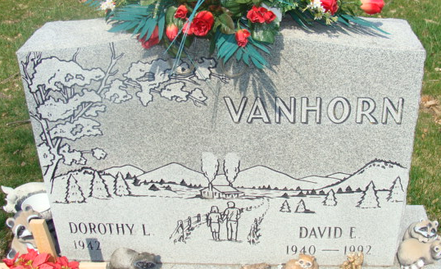
Photo by Alicia Kneuss

Dorothy Lorraine Geyer
in the Indiana, U.S., Birth Certificates, 1907-1944
Name Dorothy Lorraine Geyer
Gender Female
Birth Date 23 Jan 1942
Birth Place Decatur, Adams, Indiana, USA
Father Eli Geyer; age 48
Mother Lydia Steffen; age 45; 11th child, all living
Registration Year 1942
Certificate Number 488
Roll number 60871.IDX.002_I1415106
Volume Range 1-5

