David E. Vanhorn
December 21, 1940 – September 16, 1992

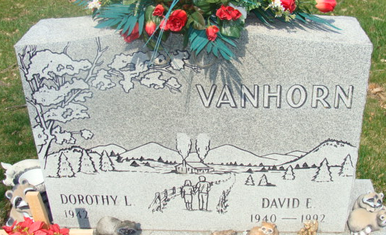
Photo by Alicia Kneuss

DECATUR – David E Vanhorn, 51, died at 3:15 pm Wednesday at Lutheran Hospital, Fort Wayne. He retired in 1987 from Pace Arrow, Decatur.
Surviving are his wife, Dorothy; two sons, Dean E. of Bluffton and Dudley S. of Decatur; a daughter, Doveanna L. Mattaridi of Fort Wayne; four brothers; Harold and Ken, both of Decatur, Bruce of Goshen and Richard of Dallas; a sister, Marilyn Weidmann of Fort Wayne; and two grandchildren.
Services at 2 pm Sunday at Haggard & Armes Funeral Home, Decatur. Calling from 2 to 5 and 7 to 9 today and Saturday. Burial in Decatur Cemetery.
Memorials to Adams County Diabetes Association, Northeastern Indiana Kidney Center, or Allen County League for the Blind.

Journal-Gazette, Allen County, Indiana
September 18, 1992

**
Indiana, U.S., Death Certificates, 1899-2017

Name David E Vanhorn
Gender Male
Race White
Age 51
Marital Status Married
Birth Date 21 Dec 1940
Birth Place Dixon, Ohio
Death Date 16 Sep 1992
Death Place Fort Wayne, Allen, Indiana, USA
Death Registration Date 1992
Father Delmar Vanhorn
Mother Lovina Schaad
Spouse Dorothy L Geyer Vanhorn, informant
Burial Decatur Cemetery September 20, 1992

