Shelby L. Vance
August 27, 1871 – June 17, 1941

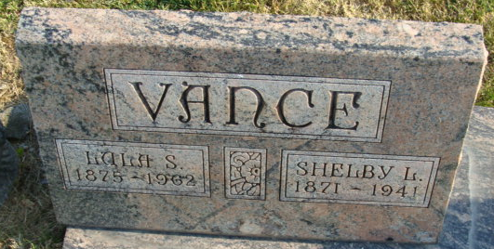
Photo by Alicia Kneuss

Shelby L Vance
in the Indiana, Death Certificates, 1899-2011
Name: Shelby L Vance
Gender: Male
Race: White
Age: 69
Marital Status: Married
Birth Date: 27 Aug 1871
Birth Place: Blue Creek Tounsphi Ind
Death Date: 17 Jun 1941
Death Place: Decatur, Adams, Indiana, USA
Father: Robert Vance
Mother: Martha Edwards
Spouse: Lula Mann
Burial: June 20, 1941 Decatur Cem., Decatur, Ind.

