Oscar Lee Vance
October 15, 1874 – March 5, 1940

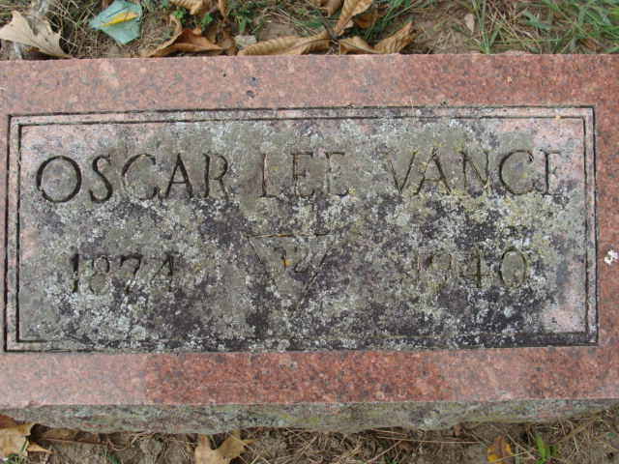
Photo by Alicia Kneuss

Oscar L. Vance Dies at Decatur Heart Disease Fatal to Businessman

Decatur, Mar. 5 – Oscar Lee Vance, 65, prominent in local business, educational and political circles for many years, died at 6:10 o’clock tonight at his home here after an illness of five days with heart disease following influenza. He had been in the clothing business here for 38 years and was senior member of the firm of Vance & Linn. A native of Blue Creek Township, Mr. Vance was graduated from Tri-State College and attended Valparaiso, following which he was principal of the ward schools here and also taught in the local high school. An active Democrat, he served on the city council and school board and was a member of the Methodist Church and the Masonic, K. of P. and Moose Lodges.
Surviving are the widow, Mrs. Anna Vance; one daughter, Mrs. Sam Merwin of New York City; one grandson and one half-brother, Shelby Vance of near Willshire, O.
Funeral services will be held Friday at 2 pm at the residence and at 2:30 pm at the First Methodist Church with Rev. R. W. Graham officiating. Burial will be in Decatur Cemetery. The body is at Zwick Funeral Home here and will be returned to the residence Wednesday.

Journal-Gazette, Allen County, Indiana
March 6, 1940

**
RITES FOR PROMINENT DECATUR MAN PLANNED

Funeral services for Oscar Lee Vance, 65, prominent local business, educational and political leader, who died at 6:10 p.m. Tuesday at his home in Decatur, will be held at 2 p.m. Friday at the residence, and at 2:30 p.m. at the First Methodist Church, the Rev. R. W. Graham officiating. Born in Bluecreek Township, Mr. Vance was graduated from Tri-State College. He was principal of ward schools here and taught in Decatur High School before entering the clothing business which he followed for 38 years. He was a senior member of the firm of Vance & Linn. Mr. Vance served on the city council and school board and was a member of the Methodist church, and the Masonic, K. of P., and Moose lodges.
Surviving are the (cut off)

Adams County Historical Museum, Adams County, Indiana
February - December 1940 Scrapbook
Handwritten date: Wednesday, March 6, 1940

**
O. L. VANCE IS TAKEN BY DEATH TUESDAY NIGHT
Prominent Decatur Clothier Dies after Short Illness

Oscar Lee Vance, 65, prominent in civic and business affairs of Decatur for nearly half a century, died at his home, 603 North Second street, Tuesday evening at 6:30 o'clock.
Mr. Vance suffered a severe heart attack last Friday night, and little hope was held for his recovery at that time. Mr. Vance, senior member of the clothing firm of Vance & Linn, was born in Blue Creek Township October 15, 1874, the son of Robert and Jane Vance. He had lived in Decatur for the past 50 years.
He was a graduate of Tri State College at Angola and later attended Valparaiso University. He was principal of Decatur ward schools for four years and also taught one year in the Decatur High School. Mr. Vance first entered the clothing business in 1902, becoming junior partner in the Elzey, Acker & Vance store. This business is still located in its original room at the northeast corner of Madison and Second Streets.
Always interested in civic affairs, Mr. Vance served six years on the city board of education, and for nine years on the city council. He was a deep student of history, especially Indian lore, and was a frequent speaker on this subject in the schools of the city and county. Mr. Vance was an active member of the First Methodist church of this city, having taught a men's Bible class for many years. Fra- (cut off)
He is survived by the widow, formerly Anna Sellemeyer, one daughter, Mrs. Sam Merwin, Jr., of New York City, and one grandson, Mather Merwin, and a half-brother, Shelby Vance, of near Willshire, Ohio.
Funeral services will be held at the home at 2 o'clock Friday afternoon and at 2:30 p.m. at the church, with Rev. R. W. Graham, pastor, officiating. Burial will be in the Decatur Cemetery. The body will be removed from the Zwick Funeral Home to the residence at 4:30 o'clock this afternoon and may be viewed until time of the funeral.

Adams County Historical Museum, Adams County, Indiana
February – December 1940 Scrapbook
Handwritten date: Wednesday, March 6, 1940
**

VANCE FUNERAL RITES HELD THIS AFTERNOON

Funeral services were held this afternoon for Oscar L. Vance, prominent Decatur merchant, who died Tuesday night at his home in this city. Services were held at the home and at the First Methodist church with Rev. R. W. Graham, church pastor, officiating. Burial was made in the Decatur cemetery. Honorary pallbearers were French Quinn, John H. Tyndall, George Flanders, C. D. Lewton, Henry Schulte, and Fred V. Mills. Active pallbearers were George Thoms, M. A. Frisinger, Cal E. Peterson, Leo Kirsch, Wendell Macklin and A. D. Suttles.

Adams County Historical Museum, Adams County, Indiana
February – December 1940 Scrapbook
Handwritten date: Friday, March 8, 1940
**

In Memory of Oscar Lee Vance
"He is not dead. Such souls forever live In boundless measure of the love they give." On the evening of March 5th, 1940, the soul of our friend and brother, Oscar Lee Vance, peacefully slipped away to see its Maker, bringing to a close a life filled with noble deeds, inspiring thoughts and unselfish services for this fellow man. For two score years Mr. Vance had been a faithful member of this church and church-school, never hesitating nor declining to do his full part in carrying on the work. He was a regular attendant at the church services, a member of the board of stewards, and of important church committees. In the church school he was ever active; his thorough knowledge of the Bible and history, his ability as a teacher, and his faith in God, made him always a welcomed teacher before any class. He was a charter member of the Co-Workers class, and served many years as one of the teachers, and was so serving at the time of his death. He also organized, taught and carried on by himself for a number of years a teachers training course which was attended by Christian workers from all churches. At a time when his services are seemingly most needed, he is called away; but it is "God's will not ours be done," however. "This is the state of man; today he puts forth The tender leaves of hope, tomorrow blossoms, And bears his blushing honors thick upon him, And the third day comes - he falls!" And so Mr. Vance has fallen into a sleep only to be awakened in that house not made with hands, eternally in the Heavens, leaving as our remembrance of him, the record of a well spent life, unspotted before the world. To his devoted wife, his daughter, his grandson and to his other relatives and host of friends, the Co-Workers class of the First Methodist church of Decatur, extends as words of comfort, the assurance of the Master as we have heard the words quoted by Mr. Vance, and being the assurance which we know frequently comforted him: "Let not your heart be troubled, Ye believe in God, believe also in me." "Come unto me, all ye that are heavy laden and I will give ye rest." Read, approved and unanimously adopted by the Co-Workers class, at the regular Sunday morning services, this 10th day of March, 1940. W. A. Fonner, president. Attest: Giles V. Porter, secretary.

Adams County Historical Museum, Adams County, Indiana
February – December 1940 Scrapbook
Handwritten date: Wednesday, March 13, 1940
**

Indiana, U.S., Death Certificates, 1899-2017
Name Oscar Lee Vance
Gender Male
Race White
Marital Status Married
Age 65
Birth Date 15 Oct 1874
Birth Place Blue Cucktwp Adams Co Indiana
Death Date 5 Mar 1940
Death Place Decatur, Adams, Indiana, USA
Death Registration Date 1940
Father Robert Vance
Mother Jane Porter
Spouse Anna Sellemeyer
Informant Mrs. Anna Vance; Decatur, Indiana
Burial March 8, 1940; Decatur Cemetery; Decatur, Indiana

