Mary Maxine Vance
July 15, 1930 – August 4, 1930

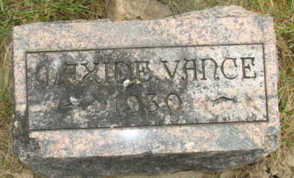
Photo by Alicia Kneuss

Mary Maxine Vance
in the Indiana, Death Certificates, 1899-2011
Name: Mary Maxine Vance
Gender: Female
Race: White
Age: 0
Birth Date: 15 Jul 1930
Birth Place: Markle Ind.
Death Date: 4 Aug 1930
Death Place: Ft. Wayne, Allen, Indiana, USA
Father: Dr. Walter Vance
Mother: Dorthy Moore
Burial: Aug. 4, 1930 Decatur Cem.

