Lula Susana (Mann) Vance
September 24, 1875 – February 28, 1962

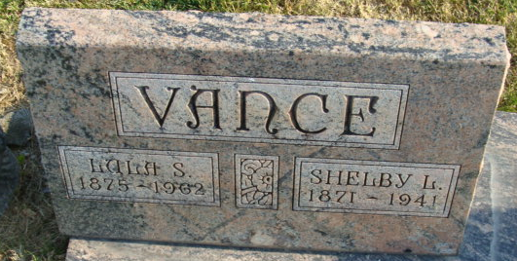
Photo by Alicia Kneuss

Lula Susana Vance
in the Indiana, U.S., Death Certificates, 1899-2017
Name Lula Susana Vance
[Lula Susana Mann]
Gender Female
Race White
Marital Status Widowed
Age 86
Birth Date 24 Sep 1875
Birth Place Adams County, Indiana
Death Date 28 Feb 1962
Death Place Fort Wayne, Allen, Indiana, USA
Death Registration Date 1962
Father Joseph E Mann
Mother Louisia Kiess
Informant Mrs. Alton Bloom; daughter; Fort Wayne, Indiana
Burial March 2, 1962; Maplewood Cemetery; Decatur, Indiana

