Geraldine Alberta Elizabeth Vance
October 23, 1904 – October 30, 1904

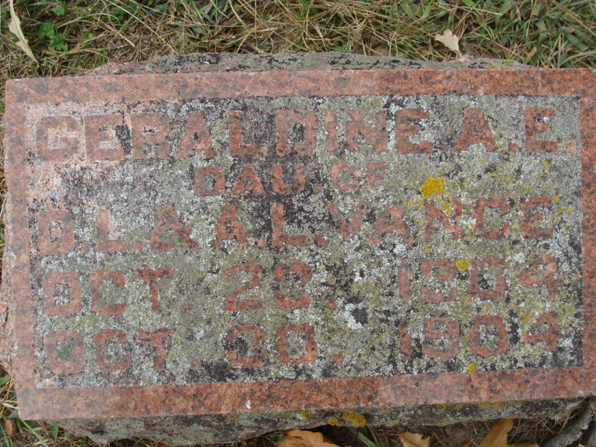
Photo by Alicia Kneuss

Geraldine Alberta Elizabeth Vance
in the Indiana, Death Certificates, 1899-2011
Name: Geraldine Alberta Elizabeth Vance
Gender: Female
Race: White
Age: 0
Birth Date: 23 Oct 1904
Birth Place: Decatur Ind
Death Date: 30 Oct 1904
Death Place: Decatur, Adams, Indiana, USA
Father: O. ?. Vance
Mother: Anna Sellemeyer
Burial: Oct. 30, 1904 Maplewood Cemetery

