Anna Louise (Sellemeyer) Vance
March 23, 1881 – June 20, 1967

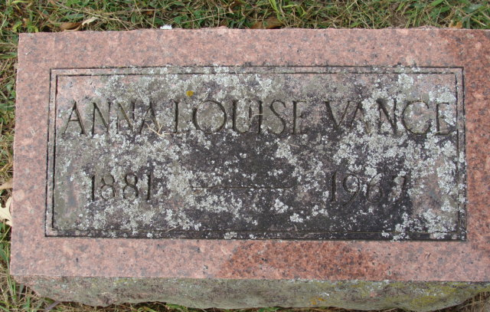
Photo by Alicia Kneuss

Anna Vance
in the Indiana, U.S., Death Certificates, 1899-2017
Name Anna Vance
[Anna Sellemeyer]
Gender Female
Race Caucasian
Marital Status Widowed
Age 86
Birth Date 23 Mar 1881
Birth Place Indiana
Death Date 20 Jun 1967
Death Place Decatur, Adams, Indiana, USA
Death Registration Date 1967
Father Frederick Sellemeyer
Mother Elizabeth Miller
Informant ??; daughter; California
Burial June 23, 1967; Decatur Cemetery; Decatur, Indiana

