Jonathan Wade Van Cleve
February 29, 1980 – March 14, 1985

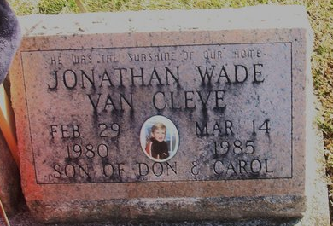
Photo by Alicia Kneuss

Jonathan Wade Van Cleve, 5 year old, died Thursday following an automobile accident near Woodburn, IN. He was preceded in death by his brother Christopher James Van Cleve.
Surviving are his parents, Donnie and Carol Ann Spangler-Van Cleve. Also surviving are his maternal grandparents Mr. and Mrs. Charles Spangler of Decatur, and his paternal grandparents Mr. and Mrs. James Van Cleve of Antwerp, OH and his maternal great-grandmother, Mrs. Beatrice Homan of Decatur, IN.
Funeral services in Decatur Cemetery Chapel, with Rev. Fred Bunts officiating.

Decatur Daily Democrat, Adams County, Indiana
March 15, 1985

**
Indiana, U.S., Death Certificates, 1899-2017
Name Johathan Wade Van Cleve
Gender Male
Race White
Marital Status Never Married (Single)
Age 5
Birth Date 29 Feb 1980
Birth Place Indiana
Death Date 14 Mar 1985; auto accident
Death Place S of Woodburn, Allen, Indiana, USA
Death Registration Date 1985
Father Donnie Van Cleve
Mother Carol Spangler
Informant Carol Van Cleve; mother; Payne, Ohio
Burial March 18, 1985; Decatur Cemetery; Decatur, Indiana

