Christopher James Van Cleve
July 17, 1978 – July 18, 1978

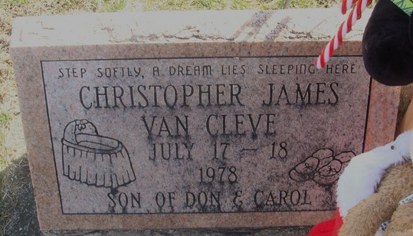
Photo by Alicia Kneuss

Christopher James Van Cleve, day-old son of Donnie and Carol Ann Spangler-Van Cleve, died at 9:30 a.m. Tuesday in Parkview Memorial Hospital, Fort Wayne.
Surviving are the maternal grandparents Mr. and Mrs. Charles Spangler of Decatur, and the paternal grandparents, Mr. and Mrs. James Van Cleve of Antwerp, Ohio. Also surviving is a maternal great-grandmother, Mrs. Beatrice Homan of Decatur.
Graveside funeral services were held at the Decatur Cemetery, with Rev. Fred Bunts officiating.

Decatur Daily Democrat, Adams County, Indiana
July 19, 1978

**
Indiana, U.S., Death Certificates, 1899-2017
Name Christopher James Van Cleve
Gender Male
Race White
Age 1 day
Birth Date 17 Jul 1978
Birth Place Indiana
Death Date 18 Jul 1978
Death Place Fort Wayne, Indiana, USA
Death Registration Date 1978
Father Donnie Vancleve
Mother Carol Ann Spangler
Informant Donnie Van Cleve; Decatur, Indiana
Burial July 19, 1978; Decatur Cemetery; Decatur, Indiana

