Anna (Reusser) VanCamp-Tremp
November 21, 1873 – March 21, 1956

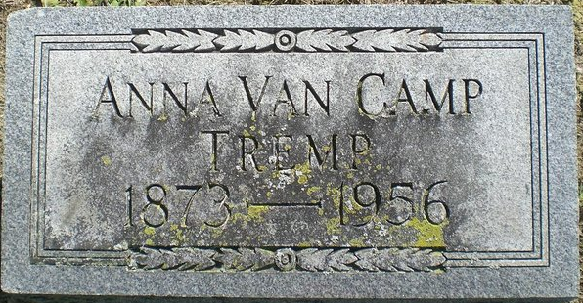
Photo by Alicia Kneuss

Widow of Frank Tremp Dies at Adams County Hospital
Rites Here Saturday For Local Woman, 82
Mrs. Anna Reusser Tremp, the widow of Frank Tremp, died at 5:45 Wednesday at the Adams County Memorial Hospital following an illness of six weeks.
She resided on North Jefferson Street, having lived in Berne for the last six years. Most of the rest of her life was spent in French Township. Mrs. Tremp was born in Switzerland Nov. 21, 1873, the daughter of Christian and Elizabeth Reusser. She came to this community at the age of 11. Her first husband was Belus VanCamp and later she married Mr. Tremp.
Surviving are the following children: Lewis A. VanCamp, Fort Wayne; Royal H. VanCamp, Willshire Ohio; Harold E. VanCamp, Fort Wayne; Mrs. Orval Slusher, Decatur; step-children are Mrs. Lloyd Wright, Craigville; Mrs. John Fryback, Bluffton; Elmer and Russel Tremp, both of Richmond; George Tremp, Marshall, Michigan; Mrs. Howard Cro?? Vera Cruz and Mrs. Herman Schug, Berne; 16 grandchildren; a brother, Albright Reusser, Ohio City, Ohio and a sister, Mrs. Christ Bischoff, Albion, Michigan.
The body is at the Yager Funeral Home where friends may call and where services will be held at 2:00 p.m. Saturday. Rev. C. A. Schmid, pastor of the Cross Evangelical and Reformed Church, of which she was a member, will officiate and burial will be in the Decatur Cemetery.

Adams County Historical Museum, Adams County, Indiana
March 1955 – April 1958 Scrapbook
Handwritten date: Friday, March 23, 1956

**
Funeral Saturday For Anna R. Tremp
Berne Woman Dies At Local Hospital

Funeral services will be held Saturday for Mrs. Anna Reusser Tremp, 82, of Berne, who died Wednesday night at the Adams County Memorial Hospital after an illness of three weeks. She was born in Switzerland March 21, 1873, a daughter of Christian and Elizabeth Reusser, and came to Adams County at the age of 11. She was married twice, to Velus Van Camp and Frank Tremp, both of whom preceded her.
Mrs. Tremp was a member of the Evangelical Reformed Church at Berne.
Surviving are three sons, Lewis A. and Harold E. VanCamp, both of Fort Wayne, and Royal H. VanCamp of Willshire, O.; a daughter, Mrs. Orval Slusher of Decatur; three stepsons, Elmer and Russell Tremp of Richmond and George Tremp of Marshall, Mich.; four stepdaughters, Mrs. Lloyd Wright of Craigville, Mrs. John Fryback of Bluffton, Mrs. Howard Croyo of Vera Cruz, and Mrs. Herman Schug of Berne; a brother, Albright Reusser of Ohio City, O.; a sister, Mrs. Christ Bischoff of Albion, Mich., and 16 grandchildren.
Services will be held at 2 p.m. Saturday at the Yager Funeral Home, the Rev. C. A. Schmid officiating. Burial will be in the Decatur Cemetery.

Decatur Daily Democrat, Adams County, Indiana
Friday, March 23, 1956

**
Marriage • Indiana Marriages, 1811-2019
Name Frank W Tremp
Sex Male; Residence Place Bluffton, ,; Race White
Birth Date 26 Mar 1876; Birthplace , Wells,
Number of Previous Marriages 2nd
Father's Name Leonard Tremp; Mother's Name Katie Bucher
Spouse's Name Anna Vancamp
Spouse's Sex Female; Spouse's Residence Place Decatur, , Indiana
Spouse's Race White
Spouse's Birth Date 21 Nov 1873; Spouse's Birthplace , , Switzerland
Spouse's Previous Marriage Number 2nd
Spouse's Father's Name Christian Reusser; Spouse's Mother's Name Anna Elizabeth Glatz
Officiator's Name Guy T Walters
Marriage Place Adams, Indiana
Marriage License Date 26 Mar 1932
Marriage License Place Adams, Indiana; Page 186; Number of Images 1

