Ruth Charlotte VanCamp
March 11, 1907 – August 26, 1909

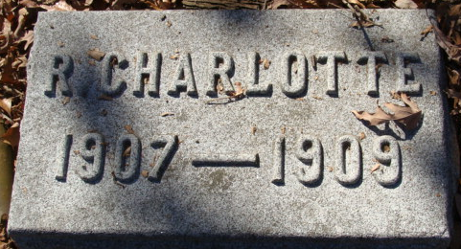
Photo by Alicia Kneuss

THREE LIVES ENDED
Daughter of Mr. and Mrs. Van Camp Died Yesterday
ILL A SHORT TIME
Day Old Child of Mr. and Mrs. John S. Cramer is Dead

Ruth Charlotte, three years old daughter of Mr. and Mrs. A. Van Camp died yesterday morning at eleven-twenty-five o'clock after suffering for less than a day from a complication of diseases peculiar to infancy. The child was taken ill Wednesday evening at seven o’clock and was subjected to severe spasms, later her condition growing weaker with the passing of each hour. Physicians were unable to diagnose the case, inasmuch as the ailment had not sufficiently developed for a thorough examination.
The little girl was born March 11th, 1907.
The parents and family are grief stricken over the sad death. The funeral services will be held from the home tomorrow afternoon at four o’clock, the Rev. Wise officiating and interment will be made at the Decatur cemetery.

Decatur Daily Democrat; Adams County, Indiana
Friday, August 27, 1909

**
Indiana, U.S., Death Certificates, 1899-2017
Name Ruth Charlotte Vancamp
Gender Female
Race White
Marital Status Single
Age 2
Birth Date 11 Mar 1907
Birth Place Decatur, Indiana
Death Date Illegible
Death Place Decatur, Adams, Indiana, USA
Father Anson VanCamp
Mother Laure Cinquemani??
Informant Anson VanCamp; Decatur, Indiana
Burial Can't read date; Maplewood Cemetery

