Lovina A. (Hoagland) Van Camp
August 14, 1880 – June 25, 1913

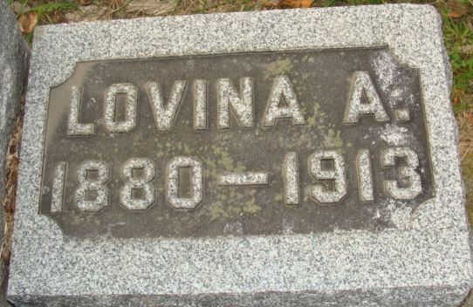
Photo by Alicia Kneuss

A telegram was received from Ben Hoagland this morning by his mother, Mrs. Amelia Hoagland, that the body of Mrs. J. D. VanCamp would arrive in the city at 3:10 o'clock this afternoon from Anderson. The exact time of the funeral has not yet been set but it is thought that it will be held Friday with services at the Hoagland home.
Mrs. J. D. VanCamp died Wednesday morning in the Anderson Hospital, where she had undergone an operation a few days ago but never recovered. The cause of her sickness or death was not mentioned in the telegram.
No further word about the funeral arrangements were received at the time of going to press.

Decatur Daily Democrat, Adams County, Indiana
June 26, 1913

**
Indiana, U.S., Death Certificates, 1899-2017

Name Lovina A. Van Camp
Gender Female
Race White
Marital Status Married
Age 32
Birth Date 14 Aug 1880
Birth Place Indiana
Death Date 25 Jun 1913
Death Place Anderson, Madison, Indiana, USA
Death Registration Date 1913
Father William Hoagland
Mother Amelia Gise Hoagland
Spouse Joseph D. Van Camp, informant
Burial 6/27/1913 Decatur, IN

