Belus Eugene Van Camp
December 29, 1861 – August 30, 1923

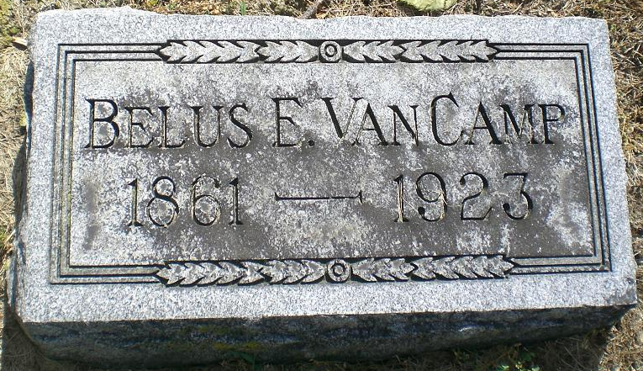
Photo by Deb Curry

ROOT TOWNSHIP FARMER EXPIRES
Belus Eugene Van Camp Dies This Morning After a Brief Illness
Belus Eugene Van Camp, 61, well known farmer residing in Root Township, two miles northeast of this city, died at 5 o'clock this morning, following a brief illness of perforation of the bowels. Mr. Van Camp had been ill since last Saturday. Mr. Van Camp was born in Allen County, December 29, 1861. He was the son of Mr. and Mrs. Daniel Van Camp. He was married twice, his first wife dying several years ago. Mr. Van Camp has two children by his first wife, they being Mrs. Orpha Wright of Sidney, Indiana and Mrs. Hazel Fryback, of Bluffton.
His second wife, Anna Reusser Van Camp survives. There are four children by the second marriage. They are Lewis, Royal and Harold Van Camp, all of Fort Wayne, and Clara Van Camp at home. The following brothers and sisters survive, also: George and Willis Van Camp, of Jackson, Mich.; Joseph Van Camp of Anderson; Lucille Shultz, of Eaton Rapids, Michigan; Maye Snyder of Russ Junction, Michigan. Two brothers and two sisters preceded him in death. Mr. Van Camp's mother, now Mrs. John Robinson, lives at Vera Cruz.
Funeral services will be conducted from the Zion Reformed Church in this city at 2 o'clock Sunday afternoon, the Rev. R. R. Elliker, pastor of the church officiating. Burial will be made in the Decatur Cemetery.

Decatur Daily Democrat, Adams County, Indiana
August 30, 1923

**
Belus Eugene Van Camp was born Dec. 29th, 1861, in Allen County, Indiana and passed out of this life into the Great Beyond Aug. 30, 1923, thus reaching the age of 61 years, 8 months and one day. He was the son of Mr. and Mrs. Daniel Van Camp. The deceased was married twice, his first wife dying more than twenty-five years ago.
He leaves to mourn his demise, his sorrowing wife, Mrs. Anna Van Camp, his aged mother, Mrs. John Robinson of Vera Cruz; two daughters by his first marriage, Mrs. Orpha Wright, of Sidney, Indiana, and Mrs. Hazel Fryback, of Bluffton; three sons and one daughter by his second marriage, Lewis, Royal, Harold and Clara Van Camp; also, three brothers and two sisters, besides a host of other relatives and friends.
Mr. Van Camp had been in poor health for some time. About a week ago his condition became decidedly worse, but it was not expected that the illness would prove fatal. However, quite unexpectedly, his death resulted from perforation of the bowels on Thursday morning, when his soul took flight into the Great Beyond, and he was relieved from his sufferings.
Decatur Daily Democrat, Adams County, Indiana
Wednesday, September 5, 1923

