Reba M. (Ramey) Valentine
December 22, 1899 – March 17, 1979

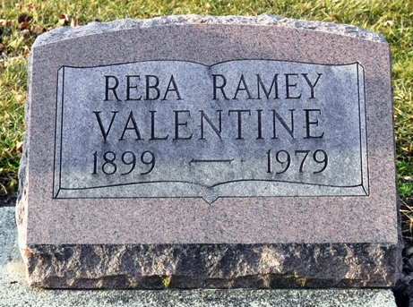
Photo by Deb Curry

Reba M. Valentine, 79, of 227 East Branning Ave. died at 10:35 p.m. Saturday in her home. She was a native of Decatur.
Surviving are one son, William R. Steffey, Fort Wayne; one daughter, Marrietta Whalen, Waveland; one sister, Margaret Gunther (sic), Fort Wayne; and two brothers, Joseph Ramey, Fort Wayne and Ralph Ramey, Sarasota, Fla.
Services will be at 3 p.m. Tuesday in Zwick Funeral Home, Decatur. Friends may call after 12 p.m. Tuesday in the funeral home. Burial will be in Decatur Cemetery.

Journal-Gazette, Allen County, Indiana
March 19, 1979
**
Reba M. Valentine, 79, of Fort Wayne, a native of Decatur, died at 10:35 p.m. Saturday at her home. She had been in failing health for several months. Born in Decatur on Dec. 22, 1899, she was the daughter of William and Laura Barnett-Ramey, and lived in Fort Wayne most of her life.
Survivors include two children: William R. Steffey, Fort Wayne; Mrs. Wallace (Marrietta) Whalen, Waveland, Ind.; one sister, Mrs. Raymond (Margaret) Guenther, Fort Wayne; and two brothers, Joseph Ramey, Fort Wayne and Ralph Ramey, Sarasota, Fla.
Funeral services will be held Tuesday at 3 p.m. at the Zwick Funeral Home, with Rev. Sylvester Martin officiating. Burial will be in the Decatur Cemetery. Friends may call at the funeral home after noon on Tuesday.

Decatur Daily Democrat, Adams County, Indiana
Monday, March 19, 1979

