Christena B. (Railing) Vail-Wicks
July 1, 1863 – January 21, 1956

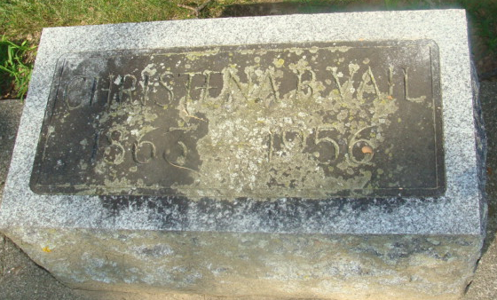
Photo by Alicia Kneuss

Christina Wicks Is Taken By Death
Prominent Decatur Lady Dies Saturday

Mrs. Christina Vail Wicks, 92, of 249 North Seventh Street, lifelong resident of Decatur, died at 10:25 o'clock Saturday night at the Adams County Memorial Hospital. Mrs. Wicks had been in critical condition since sustaining a fractured hip in a fall eight days ago.
A native of Adams County, she was born July 1, 1863, a daughter of Mr. and Mrs. Daniel Railing. Her husband, Edward, preceded her in death.
Mrs. Wicks was one of the most active members of the First Methodist Church in this city and was also prominent for many years in social and civic affairs in Decatur.
Surviving are two sons, Daniel R. Vail of Miami, Fla., and Forrest E. Vail of Leesburg; one grandchild and four great-grandchildren. One son, Thomas Vail, and one sister are deceased.
Funeral services will be conducted at 2 p. m. Tuesday at the First Methodist Church, the Rev. Virgil W. Sexton officiating. Burial will be in the Decatur Cemetery. The body was removed to the Gillig & Doan Funeral Home, where friends may call after 4 o’clock this afternoon until time of the services.

Decatur Daily Democrat; Adams County, Indiana
Monday, January 23, 1956

