Hugh Thomas Vail
September 11, 1890 – February 14, 1953

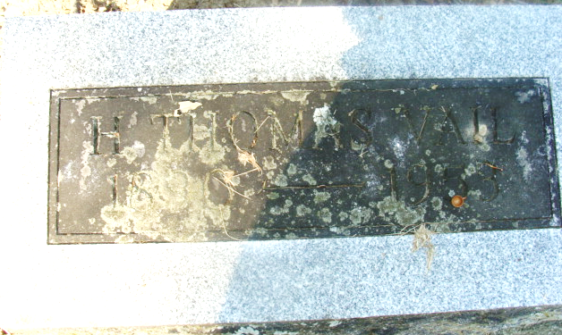
Photo by Alicia Kneuss

Hugh Thomas Bril
in the Indiana, U.S., Death Certificates, 1899-2017
Name Hugh Thomas Vail
Gender Male
Race White
Marital Status Married
Age 62
Birth Date 11 Sep 1890
Birth Place Indiana
Death Date 14 Feb 1953
Death Place Decatur, Adams, Indiana, USA
Death Registration Date 1953
Father John Vail
Mother Christein Sprang Railing
Informant Christina Wicks; Decatur, Indiana
Burial February 17, 1953; Decatur Cemetery; Decatur, Indiana

