Grace I. (Butler) Vail
June 18, 1896 – December 23, 1990

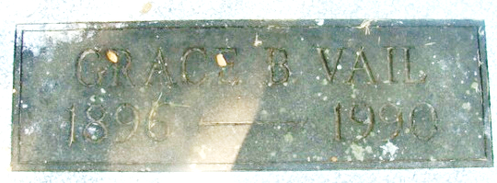
Photo by Alicia Kneuss

Grace I Vail
in the Indiana, U.S., Death Certificates, 1899-2017
Name Grace I Vail
[Grace I Butler]
Gender Female
Race White
Marital Status Widowed
Age 94
Birth Date 18 Jun 1896
Birth Place Decatur, Indiana
Death Date 23 Dec 1990
Death Place Syracuse, Kosciusko, Indiana, USA
Death Registration Date 1990
Father Melvin Butler
Mother Nora Rice
Informant Marjorie Link; no relation; North Webster, Indiana
Burial December 26, 1990; Maplewood Cemetery; Decatur, Indiana

