Mary M. (Smitley) Vahey
June 24, 1922 – November 6, 2006

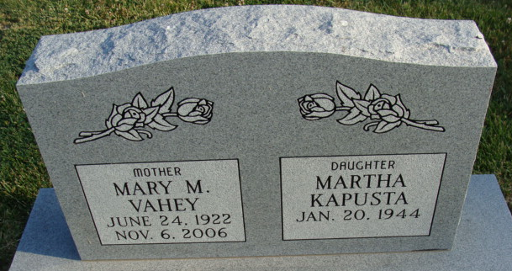
Photo by Alicia Kneuss

Mary M. Vahey, 84, Anderson, passed away November 6, 2006 at St. John’s Medical Center after a sudden illness. She was born June 24, 1922 in Decatur, the daughter of Melvin C. and Lula M. (McKean) Smitley. She had lived in Anderson since 1990.
She is survived by her daughter, Martha Kapusta; and several nieces and nephews.
She was preceded in death by her first husband, Joseph Martin Kapusta; and second husband, William Vahey.
A graveside service will be conducted at 11 am Thursday at Decatur Cemetery.

Brown-Butz Funeral Home, Anderson, Indiana
November 7, 2006

**
Indiana, U.S., Death Certificates, 1899-2017
Name Mary M Vahey
[Mary M Smitley]
Gender Female
Race White
Marital Status Widowed
Age 84
Birth Date 24 Jun 1922
Birth Place Decatur, Indiana
Death Date 6 Nov 2006
Death Place Anderson, Madison, Indiana, USA
Death Registration Date 2006
Father Melvin C Smitley
Mother Lula M McKean
Informant Martha Kapusta; daughter; Anderson, Indiana
Burial November 9, 2006; Decatur Cemetery; Decatur, Indiana

