Robert Daniel Urick
September 9, 1913 – March 16, 1976

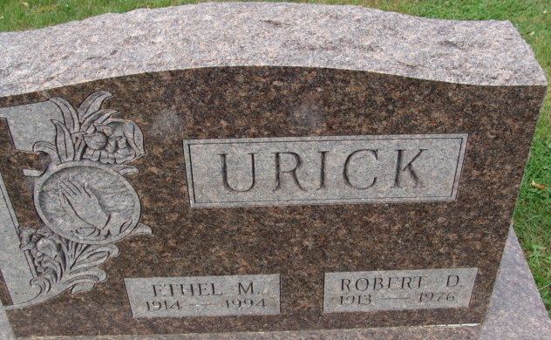
Photo by Alicia Kneuss

ROBERT URICK RITES FRIDAY

A resident of Decatur Route 6, Robert Urick, 62, died at 11:05 a.m. Tuesday at Clinic Hospital where he had been a patient three weeks. A son of George D. and Mary D. Elzey Urick, he was born Sept. 9, 1913 in Monroe Twp., Adams County. His marriage to Ethel Tumbleson, who survives, took place Sept. 14, 1935.
Mr. Urick employed as a machinist by the Fruehauf Trailer Co., of Fort Wayne, was a lifelong resident of Adams County and attended the Decatur Missionary Church.
Surviving, in addition to the wife, are a daughter, Mrs. Walter (Pat) Baumgartner of Bluffton, Route 4; four sons, Palmer D., Larry D., George E., and James A., all of Decatur; a brother, Virgil of Fort Wayne; a sister, Mrs. John (Bertha) Hirschy of Decatur, and nine grandchildren.
Calling will be after 7 p.m. at the Winteregg-Linn and Haggard Funeral Home at Decatur, where services will be at 2 p.m. Friday. Rev. Sylvester Martin and Rev. Arthur Niblick will officiate and burial will be in the Decatur Cemetery.

News Banner, Wells County, Indiana
March 17, 1976

