Palmer D. Urick
February 1, 1942 – January 30, 2008

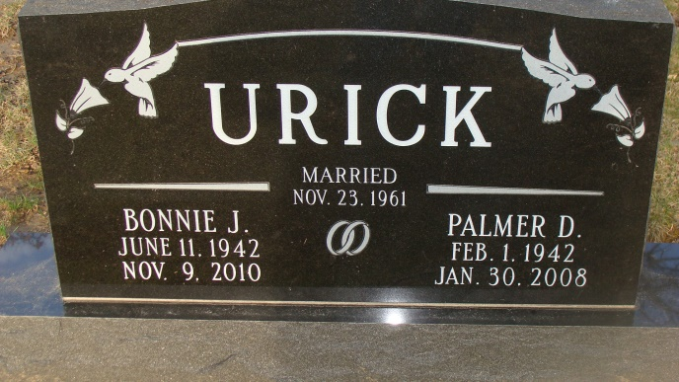
Photo by Alicia Kneuss

Palmer D. Urick, 65 of rural Decatur passed away January 30, 2008 at Adams Memorial Hospital. Palmer was born in Adams County, Indiana on February 1, 1942 to the late Robert & Ethel (Tumbleson) Urick. He married Bonnie J. Fulton on November 23, 1961, she survives.
Other survivors are 3 daughters Mrs. Greg (Julie) Kable of Lilburn, GA, Mrs. Jim (Cindy) Snider of Decatur, IN, Mrs. Stan (Cheri) Jesionowski of Apex, N.C.; 2 brothers George (Rita) Urick of Decatur, IN, James Urick of Ft. Wayne, IN.; 6 grandchildren Jacob, Megan, Benjamin Snider of Decatur; Joshua, Emily Kable of Lilburn, GA and Trent Jesionowski of Apex, N.C.. Preceded Palmer in death was a brother Larry Urick and a sister Patsy Baumgartner. Palmer attended the Bridge Community Church in Decatur.
He retired as a Tool Maker from General Electric in Ft. Wayne. Calling hours are from 3-5 & 6-8 pm Saturday, February 2, 2008 at Haggard & Sefton Funeral Home and 1 hour prior to services. Funeral service will be on Sunday, February 3, 2008 at 2:00 pm also at the funeral home Pastor Mo Hodge will be officiating and burial is in the Decatur Cemetery.
Memorials are to Adams County Heart Club or Diabetes Association.

Haggard & Sefton Funeral Home, Adams County, Indiana
February 1, 2008

