Jerry Wayne Urick
January 25, 1944 – February 16, 1944

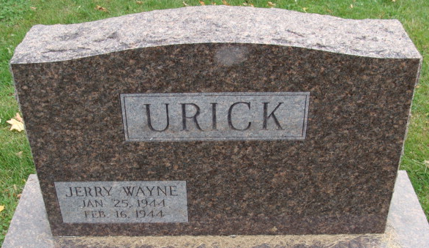
Photo by Alicia Kneuss

Jepry Wayne Wrick
in the Indiana, U.S., Death Certificates, 1899-2017
Name Jerry Wayne Urick
Gender Male
Race White
Marital Status Single
Age 21 days
Birth Date 25 Jan 1944
Birth Place Adams County, Indiana
Death Date 16 Feb 1944
Death Place Decatur, Adams, Indiana, USA
Death Registration Date 1944
Father Robert D Urick
Mother Ethel M Tumbleson
Informant Robert D. Urick; Decatur, Indiana
Burial February 18, 1944; Decatur Cemetery; Decatur, Indiana

