Freeman Urick
January 1, 1904 – November 24, 1952

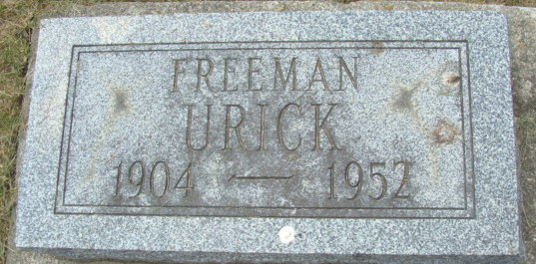
Photo by Alicia Kneuss

FREEMAN URICK BURNS TO DEATH MONDAY NIGHT
Monroe Tp. Native Meets Firey Death in Highway Accident

Freeman Urick, 48, a native of Monroe Township, burned to death underneath a heavy truck at 9:30 p.m. Monday on U.S. Highway 40, three and one-half miles east of Norwalk, Ohio. His brother, Robert Urick, 38, escaped with lesser burns and is recovering at his home in Decatur.
The dead man resided on Decatur Rural Route 6. Urick, who was well known here, was the son of the late Mr. and Mrs. George Urick and lived four miles north of Berne for many years. Urick was burned to a crisp in the mishap. The remains will not be shown. Blow torches had to be used to burn parts of the cab away to remove the badly charred body.
A semi-trailer loaded with eggs and driven by Robert Urick, left the highway after a tire blew out on the tractor. The men are employed by Decatur Farms and were enroute to Decatur with a load of eggs they had obtained at Cleveland, Ohio. The big truck rolled over three times and then caught fire in a ditch. Freeman Urick was pinned underneath. His brother, thrown from the vehicle, tried to pull Freeman to safety but could not move him. In his rescue efforts, Robert suffered severe hand, arm and face burns. He was admitted to the hospital at Norwalk, treated and then returned to his home.
Freeman Urick was employed part time by Decatur Farms. Robert Urick drove a truck for the well-known Decatur produce firm. The dead man worked part time as a plasterer’s helper. He was born north of Berne January 1, 1904. He was never married.
Surviving are two brothers, Robert and Virgil, both of Decatur; three sisters, Mrs. Daisy Martin, widow of Peter Martin, Mrs. John Hirschy and Mrs. John Mayer, all of Decatur.
The body was removed to the Gillig and Doan Funeral Home in Decatur where services will be held at 10:30 a.m. Thursday, Rev. H. J. Welty officiating. Burial will be in the Decatur Cemetery.

Adams County Historical Museum, Adams County, Indiana
September 1952 – December 1953 Scrapbook, image 48
Handwritten Date: Wednesday, November 26, 1952

