Ethel Marcella (Tumbleson) Urick
June 11, 1914 – March 6, 1994

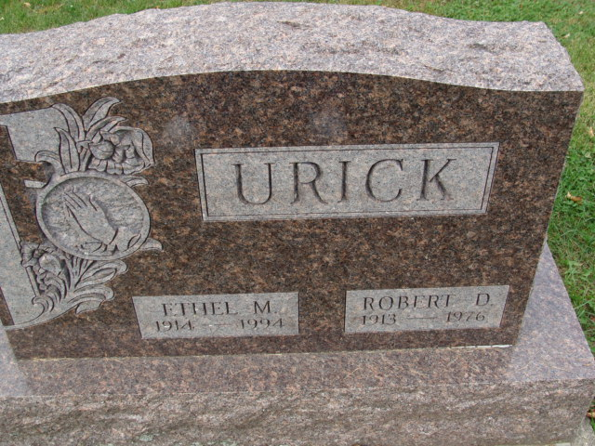
Photo by Alicia Kneuss

Ethel M. Urick, 79, of Decatur died Sunday in Adams County Memorial Hospital. The Adams County native was a homemaker and worked at the Golden Meadows Home, formerly the Adams County Home. She was the widow of Robert D., who died in 1976.
Surviving are her sons, Palmer D., Larry R. and George E., all of Decatur, and James A. of Fort Wayne; sisters, Velma Bailey of Sun City, Ariz., Olive Hendricks and Arbie Hart, both of Berne; 12 grandchildren; and eight great- grandchildren.
Services are 11 a.m. Wednesday at Haggard & Armes Funeral Home, Decatur, where calling is 2 to 5 and 7 to 9 p.m. tomorrow. Burial will be in Decatur Cemetery.
Preferred memorials are gifts to Adams County Home Health Care.

News-Sentinel, Allen County, Indiana
March 7, 1994

