Bonnie J. (Fulton) Urick
June 11, 1942 – November 9, 2010

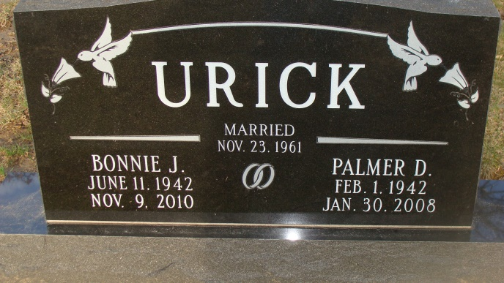
Photo by Alicia Kneuss

Bonnie J. Urick, 68, of Decatur, Indiana died on Tuesday, November 9, 2010 at Lutheran Hospital. Bonnie was born on June 11, 1942 in Bluffton, Indiana to Oral Fulton and Mary Ann (Nash) Fulton Holthouse. On November 23, 1961 she married Palmer D. Urick. He preceded her in death on January 30, 2008. Bonnie attended the Bridge Community church. She retired as an Accountant.
She is survived by her mother Mary Ann Holthouse of Decatur; three daughters Mrs. Greg (Julie) Kable of Lilburn, GA, Mrs. Jim (Cindy) Snider and Mrs. Stan (Cheri) Jesionowski both of Decatur, IN; a brother Thomas Fulton of Decatur, IN; two sisters Mrs. Vince (Linda) Holt of Kokomo, IN, Mrs. Max (Dianne) Elzey of Decatur, IN; six grandchildren Jacob (Darah), Megan, Benjamin Snider of Decatur; Joshua and Emily Kable of Lilburn, GA and Trent Jesionowski of Decatur. She is also preceded in death by her father.
Visitation will be on Friday, November 12, 2010 from 3-5 and 6-8 p.m. at Haggard and Sefton Funeral Home and one hour prior to services. Funeral service will be at 11:00 a.m. on Saturday, November 13, 2010 also at the funeral home. Pastor Mo Hodge will be officiating and burial will be in Decatur Cemetery.
Memorials are to Adams Central Boys Basketball or Adams County Heart Club.

Haggard & Sefton Funeral Home, Adams County, Indiana
November 10, 2010

