Ruth (Taylor) Unger-Nelson
September 4, 1837 – January 4, 1902

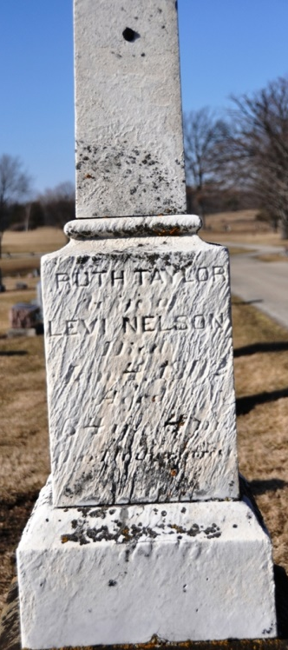
Photo by Deb Curry

Ruth Taylor was born in Auglaize County, Ohio, September 4, 1837 and died in Decatur, Indiana January 4, 1902, aged 64 years and 4 months. She was married to Henry Unger in 1853. Mr. Under (sic) died in 1855. She was married to Levi Nelson September 2, 1876.
She leaves a husband and nine children to mourn her departure. She was a faithful Christian and a member of the U.B. Church.
She said, “Let me go, that I may not tarry. Angels wait my soul to carry where my risen Lord appears. We have traveled long together hand in hand and heart to heart.”
Funeral services were conducted by Rev. Pontius. Mr. Nelson extends thanks to all his neighbors and friends for their kindness.

Decatur Democrat (a weekly newspaper)
January 9, 1902, Page 1

