Sharyl Laux (Baughn) Ulrich
August 24, 1952 – July 29, 1998

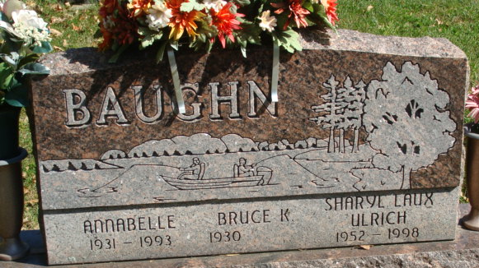
Photo by Alicia Kneuss

Sharyl S. Ulrich, 45, of Huntington, a Decatur native, died Wednesday, July 29, at home. She formerly worked for Dr. Ron Hammond.
Surviving is her husband, Melvin; her father and stepmother, Bruce and Harriet Baughn of Angola; sons Jeff Laux of Indianapolis and Joe Laux of Charlottesville, Va.; a stepson, Scott Ulrich of Huntington; a stepdaughter, Elizabeth Ulrich of Indianapolis; and a brother, David A. Baughn of Yorktown.
She was preceded in death by her mother, Annabelle Roop Baughn, in 1993.
Services are 2 p.m. Saturday at Haggard & Sefton Funeral Home, Decatur, with calling two hours before services and also from 2 to 8 p.m. today. Burial will be in Decatur Cemetery, Decatur.
Memorials are to the American Cancer Society.

News-Sentinel, Allen County, Indiana
July 31, 1998

**
Indiana, U.S., Death Certificates, 1899-2017
Name Sharyl S. Ulrich
[Sharyl S. Baughn]
Gender Female
Race White
Marital Status Married
Age 45
Birth Date 24 Aug 1952
Birth Place Decatur, Indiana
Death Date 29 Jul 1998
Death Place Huntington, Huntington, Indiana, USA
Death Registration Date 1998
Father Bruce Baughn
Mother Annabelle Roop
Spouse Melvin Ulrich
Informant Melvin Ulrich; husband; Huntington, Indiana
Burial August 1, 1998; Decatur Cemetery; Decatur, Indiana

