Gerald R. Ulman
December 4, 1935 – November 22, 2023

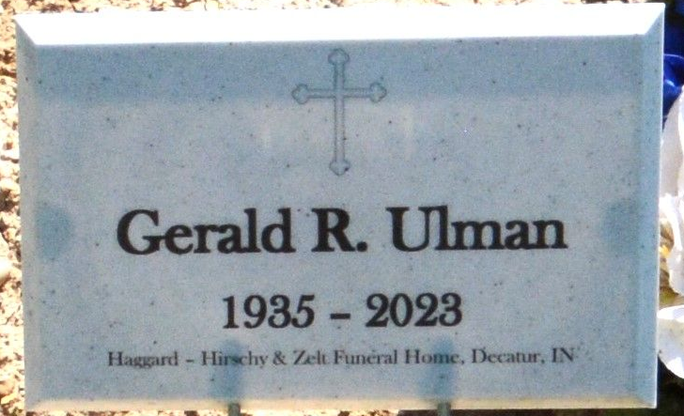
Photo by Deb Curry
Gerald R. "Big Jerry" Ulman, 87, of Decatur, IN, passed away on Wednesday, November 22, 2023, at Adams Woodcrest. He was born in Decatur, IN, on December 4, 1935, the son of the late Bernard J. “Bun” Ulman and Hilda M. (Reinking) Ulman. On July 18, 1959, he married Phylis A. Weaver.
He was a 1953 graduate of Mendon-Union High School in Mercer County, Ohio. Jerry served his country first in the United States Navy as a Medic and then joined his beloved United States Marine Corps. He attained the rank of Staff Sergeant and was based out of Camp Lejeune and served at Guantanamo Bay, Cuba. He was immensely proud to be a Marine and would tell everyone he met “Semper Fi, 2nd Marines!”
Jerry served as an officer with the Decatur Police Department for 20 years before retiring as a Sergeant in 1986. He began Ulman’s Carpet Cleaning & Restoration Services in 1966 and was the owner and operator for many decades.
He fiercely loved his family and treasured his time with them. Since 1972, Jerry and Phylis enjoyed the time spent at their cabin in the Upper Peninsula of Michigan with family and many friends. These were times filled with fishing, laughter, and love.
He was a member of Grace First Community Church. He was also a member of the American Legion Adams Post 43, V.F.W. Post 6236, Loyal Order of Moose Lodge 1311, Eagles Aerie 2653, Decatur Masonic Lodge F. & A.M. 571, and the Fraternal Order of Police.
Jerry is survived by his wife of 64 years, Phylis Ulman of Decatur; 3 children, Dave (Sherry) Ulman, Rhonda (Jeff) McIntosh, and Tim (Kelly) Ulman all of Decatur; 5 grandchildren, Danielle Ulman, Katelyn (Tyler) Engstrom, Kodee McIntosh, Nate Uman, and John Ulman; 2 great grandchildren, Max and Ella Engstrom.
He was preceded in death by a brother, Ralph Ulman and 4 sisters, Margaret Wendall, Alice Jerome, Phyllis Evard, and Marlene Weaver.
Visitation will be from 3:00 – 8:00 p.m. on Monday, November 27, 2023 at Haggard-Hirschy & Zelt Funeral Home.
A Funeral Service will be held at 11:00 a.m., on Tuesday, November 28, 2023, at Haggard-Hirschy & Zelt Funeral Home, with visitation 1 hour prior from 10:00 – 11:00 a.m. Pastor Steve Austin will be officiating and burial will follow in the Decatur Cemetery, with military graveside rites rendered by the American Legion Adams Post 43 Color Guard.
Memorials may be made to Tunnels to Towers Foundation or the American Legion Adams Post 43 Color Guard.

Haggard & Sefton Funeral Home, Adams County, Indiana
November 23, 2023

