Norma Jean (Swygart) Uhrick
July 5, 1929 – July 19, 1979

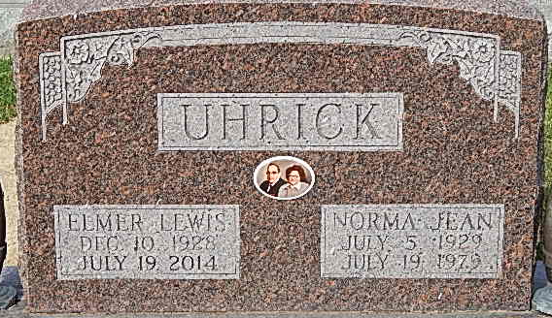
Photo by Alicia Kneuss

Norma J. Uhrick, 50, of S Main Street in Bluffton died this morning at 4 a.m. at the Caylor-Nickel Clinic from complications following an 18 year kidney ailment. Born in Decatur on July 5, 1929, she lived in Adams County until she moved to Bluffton 10 years ago. Her parents, Lafayette and Leah Dibble Swygart, preceded her in death. Mrs. Uhrick, a member of the Church of Christ in Christian Union, was married December 15, 1946 to Elmer Uhrick, who survives.
Also surviving are two daughters and two sons; Mrs. Marvin (Joyce) Wyatt, Fort Wayne; Mrs. Jerry (Judy) Wyatt, Bluffton; Kerry Uhrick, Decatur and Larry L Uhrick, Berne. Seven brothers and one sister also survive; Jack Swygart, Monroeville; Richard Swygart, South Carolina; Robert Swygart, Montpelier; Max Swygart, Willshire, Ohio; Paul Swygart, Pennsylvania; Gerald Swygart, Fort Wayne; and Lafayette Swygart, Augusta Georgia and a sister, Isabella, Van Wert, Ohio. Mrs. Uhrick had 10 grandchildren.
Funeral will be held at the Goodwin Memorial Chapel at 1:30 p.m. Saturday and will be in charge of Rev. Edwin Willett. Burial will be in the Decatur Cemetery.

Decatur Daily Democrat, Adams County, Indiana
July 19, 1979

