Ned E. Uhrick
March 3, 1938 – March 3, 1938

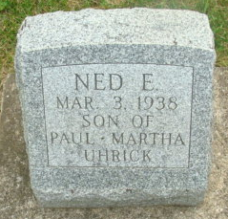
Photo by Alicia Kneuss

Ned E Uhrick from tree Rachel Family Tree
Birth 3 Mar 1938
Death 3 Mar 1938
Father Paul Samuel Uhrick (1913-1964)
Mother Martha Elizabeth Reppert (1912-2005)

