Martha E. (Reppert) Uhrick
December 19, 1912 – October 17, 2005

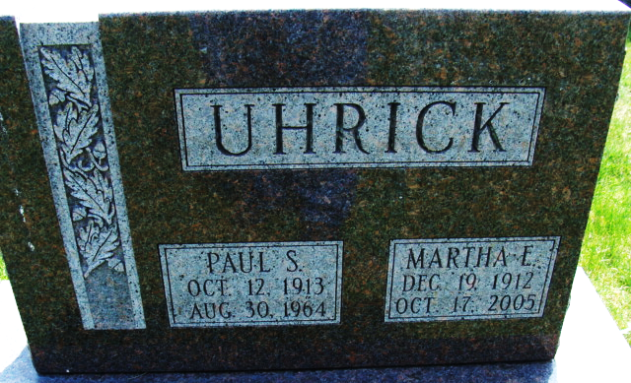
Photo by Alicia Kneuss

Martha E. Uhrick, 92, Decatur, died at home at 11:32 p.m. Monday. She was born in Adams County on December 19, 1912, to William and Emma Yost Reppert. She married Paul Uhrick on May 30, 1937; he died on August 30, 1964.
She was a former teacher, her 19-year career ending in 1978 when she retired from Monmouth Elementary School. She was a member of Zion United Church of Christ in Decatur and its Women's Guild as well as the Indiana State Teachers Association. She attended Ball State Teachers College from 1932-34, studying elementary education, and received her bachelor's degree in 1970 from St. Francis College in Fort Wayne in elementary education and social studies.
Surviving are two daughters, Mrs. Ron (Jane) Gerber of Decatur and Mrs. Jerry (Marilou) Hill of St. Clair Shores, Michigan; a son, Kenneth Uhrick of Decatur; a sister Lela Kershner of Decatur; nine grandchildren; and 13 great-grandchildren. A son, four sisters and a brother are deceased.
Funeral services will be held at 11 a.m. Friday in Zwick and Jahn Funeral Home, with burial in Decatur Cemetery. Visiting hours are 2-5 and 6-8 p.m. Thursday and 10-11 a.m. Friday.
Preferred memorials are to the church.

Decatur Daily Democrat, Adams County, Indiana
October 19, 2005

