Marcella M. (Nelson) Uhrick
August 2, 1910 – June 15, 1990

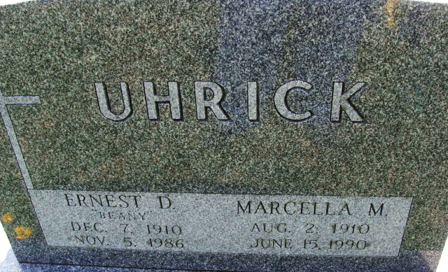
Photo by Alicia Kneuss

Marcella M. Uhrick, 79, Decorah, Iowa, a native of Monroe and a former Decatur resident, died at 5 p.m. Friday in the Asse Haugen Home at Decorah, her residence the past 3 1/2 years. She was born in Monroe on August 2, 1910 to John and Elta Mae Essex Nelson and married Ernest D. Uhrick on July 27, 1930; he died Nov. 5, 1986.
She lived most of her life in Decatur, retiring from United Telephone Co. in 1969 after some 10 years as a receptionist. In retirement, she moved to Oliver Lake, Indiana. She and her husband spent winters in Leesburg, Florida. She was formerly a member of First United Methodist Church in Decatur and was currently a member of Decorah United Methodist Church.
Surviving are a son David Uhrick, Columbus, Ohio; a daughter, Mrs. James (Ann) Rhodes, Decorah; two sisters, Mrs. Parry (Doris) McRae, 1422 W. Monroe St., and Agnes Nelson, Fruitland Park, Florida; five grandsons; one granddaughter and one great-grandson. One brother, Leigh Edward Nelson and one sister, Bernice Nelson, are deceased.
Funeral services are at 1:30 p.m. Tuesday in Zwick-Sefton and Jahn Funeral Home, Rev. John Weeks officiating. Burial will be in Decatur Cemetery. Visiting hours at the funeral home are 2-5 and 7-9 p.m. Monday.
Preferred memorials are to donor's choice.

Decatur Daily Democrat, Adams County, Indiana
June 16, 1990

